**Designing a real-time system**

**Methodology**

* Tasks’ priorities were calculated based on periodicity of the task.
* Deadlines were not mentioned so it is assumed that it is the same as the periodicity.
* CPU load calculated manually then results are validated through SIMSO.

**Tasks:**

1. LCD task {Priority: 5, Periodicity: 10, Exec. Time: 2, Deadline: 10}
2. Blood pressure task {Priority: 2, Periodicity: 25, Exec. Time: 4, Deadline: 25}
3. Heart beat task {Priority: 1, Periodicity: 100, Exec. Time: 1.5, Deadline: 100}
4. Temperature task {Priority: 4, Periodicity: 10, Exec. Time: 2.5, Deadline: 10}
5. Blood pressure task {Priority: 3, Periodicity: 10, Exec. Time: 1, Deadline: 10}

**Hyper period:**

* Based on the tasks shown above the hyper period is 100 ms

**CPU Load:**

$CPU load=\frac{∑Exec}{H}=\frac{2*10+3*4+1.5+2.5*10+1*10}{100}=0.685$

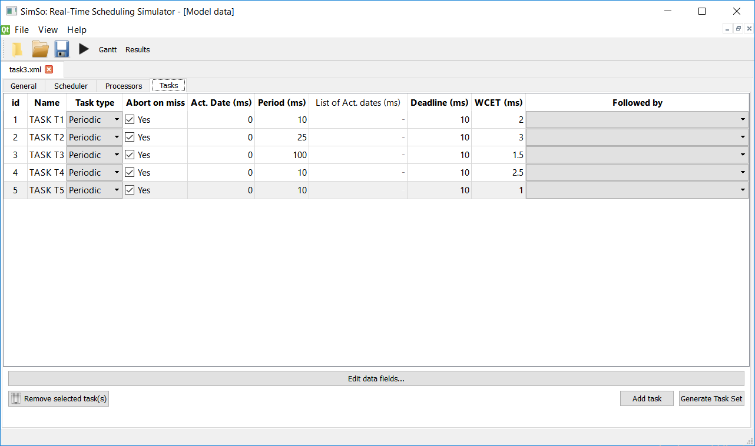**SIMSO Results:**

* Tasks simulated:
* Gantt chart:

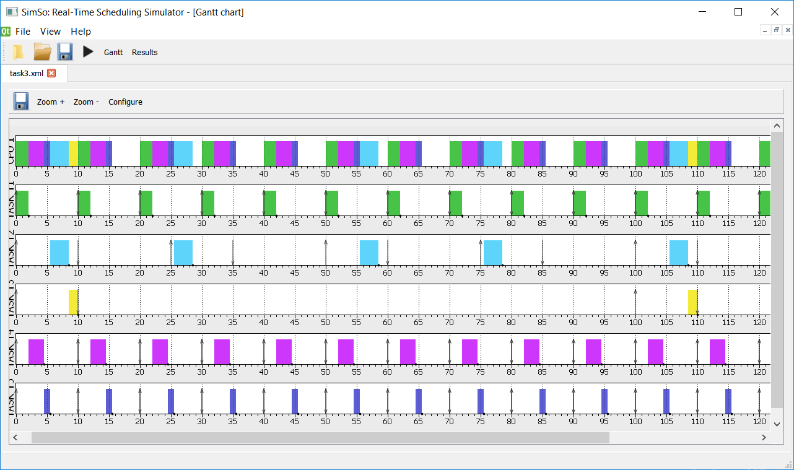

* CPU load:

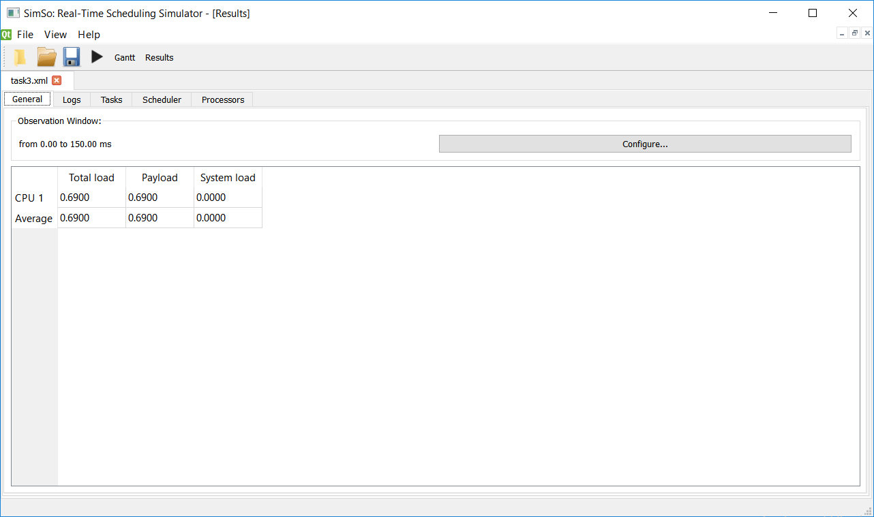

* Final comment:

Since our results conform to the SIMSO simulation and the system tasks don’t break their deadline at any point, this system is schedulable.